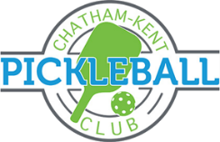

Where: Saturday Oct 28th St Clair College Chatham Campus HealthPlex 1001 Grand Ave West Chatham
When: 1:30 – 2:00 pm registration and warm up
2:00- 5:30 pm- Tournament Play
6:30 – 9:00 pm – Social Event sponsored by Stompin’ Grapes Winery with appetizers from Chilled Cork at Retro Suites “Taking Care of Business” room (included in entry fee)
Register at: www.ckpickleball.com under Events > Stompin’ Grapes
Cost: $30 NON CKPC Members $21 for CKPC member (Enter discount code CKPCMEMBER to get CKPC members rate)
Deadline: Please register by 6:00 pm Monday Oct 23rd
Format: Stompin’ Grapes Pickleball Tournament will be a fun all levels team tournament. All participants will be assigned a team and play with different team partners each match.
Prizes: Stompin’ Grapes will provide some pretty awesome prizes. There will be other prizes or goodies for the winning team.
Friends and family welcome to attend social event for $15. Register under Stompin’ Grapes Social hour online.
INFO: Email: info@ckpickleball.com
Phone: 226-626-1956
http://www.ckpickleball.com

